PHASE 1 — BRAINSTORMING & IDEATION
INTRODUCTION :
Project Title : BlogNest AI
Team ID : SWTID-2026 4186
Team Leader : Vishal A
MAIL ID: vishalken321@gmail.com
Team members :
NAME | MAIL ID
Hariprakash G | hari623406@gmail.com
Sudharshan S | Sudhansasi30@gmail.com
Problem Identified
- Writing blogs from scratch is slow, and writers often face blank-page and writer's block problems.
- Blog content, categories and drafts are scattered across many tools, so they are hard to manage.
- Manual keyword research and SEO tuning consume extra time for every post.
- Unprotected publishing systems allow unauthorised changes to private drafts.
Project Idea
Develop BlogNest AI, an AI-powered blogging assistant that centralises blog creation, management, search and AI-assisted content generation through a secure backend API.
Proposed Solution
The BlogNest AI backend provides a centralised REST API using Node.js and Express, MongoDB/Mongoose for persistence, JWT authentication for protected operations, and Google Gemini AI for automated blog title, outline and draft generation.
Objectives
- Automate blog creation and content generation using Google Gemini AI.
- Use JWT authentication and authorisation for protected routes.
- Hash passwords using bcrypt.
- Support CRUD operations for blog records.
- Improve blog discovery through search and categories.
- Maintain data integrity with Mongoose schema validation.

PHASE 2 — REQUIREMENT ANALYSIS
INTRODUCTION :
Project Title : BlogNest AI
Team ID : SWTID-2026 4186
Team Leader : Vishal A
MAIL ID: vishalken321@gmail.com
Team members :
NAME | MAIL ID
Hariprakash G | hari623406@gmail.com
Sudharshan S | Sudhansasi30@gmail.com
Functional Requirements
- User registration and login with secure authentication.
- Create, read, update and delete blog posts (CRUD).
- AI-based generation of blog titles, outlines and drafts from a topic.
- Search blogs by keyword and filter them by category or tag.
- Only the logged-in owner can edit or delete their own blogs.
Non-Functional Requirements
- Security: bcrypt password hashing, JWT-protected routes and input validation.
- Performance: fast API responses and AI results within a few seconds.
- Reliability: schema validation to keep stored data consistent.
- Maintainability: modular code split into routes, controllers, services and middleware.
Technology Requirements
Component | Technology
Runtime / Framework | Node.js and Express
Database | MongoDB with Mongoose
Authentication | JWT and bcrypt
AI Service | Google Gemini AI
Tools | VS Code, Postman, Git and GitHub, npm

PHASE 3 — PROJECT DESIGN
INTRODUCTION :
Project Title : BlogNest AI
Team ID : SWTID-2026 4186
Team Leader : Vishal A
MAIL ID: vishalken321@gmail.com
Team members :
NAME | MAIL ID
Hariprakash G | hari623406@gmail.com
Sudharshan S | Sudhansasi30@gmail.com
System Architecture
Client / Postman → Express routes → middleware (JWT check, validation) → controllers and services → MongoDB (Mongoose) and Google Gemini AI.
Database Schemas
- User – name, email, password (hashed), createdAt.
- Blog – title, content, category, tags, author (User reference), createdAt, updatedAt.
API Design
Method | Endpoint | Purpose
POST | /api/auth/register | Register a new user
POST | /api/auth/login | Login and receive a JWT
POST | /api/blogs | Create a blog (protected)
GET | /api/blogs | List blogs, with search and category filter
PUT / DELETE | /api/blogs/:id | Update or delete own blog (protected)
POST | /api/ai/generate | Generate blog content using Gemini AI (protected)

PHASE 4 — PROJECT PLANNING
INTRODUCTION :
Project Title : BlogNest AI
Team ID : SWTID-2026 4186
Team Leader : Vishal A
MAIL ID: vishalken321@gmail.com
Team members :
NAME | MAIL ID
Hariprakash G | hari623406@gmail.com
Sudharshan S | Sudhansasi30@gmail.com
The project planning follows the implementation sequence documented for BlogNest AI.
Step | Planned Work | Output
1 | Project setup and configuration | Project folder, src folder, npm configuration and dependencies
2 | Backend development | server.js, app.js, middleware, controllers/services
3 | Database configuration | User and Blog schemas; MongoDB/Mongoose connection
4 | API routing | Authentication, blog and AI route interfaces
5 | Project execution | Run backend with npm run dev
6 | API verification | Registration, login, blog creation, search and AI generation
7 | Documentation | Project report, API details, screenshots and links
8 | Demonstration | API testing and final demo video
Team Responsibility
- Vishal A (Team Leader): planning, coordination, review and final integration.
- Hariprakash G: backend development, routing and database configuration.
- Sudharshan S: AI integration, testing and documentation.
- Maintain all project work phase-wise in the public GitHub repository.

PHASE 5 — PROJECT DEVELOPMENT
INTRODUCTION :
Project Title : BlogNest AI
Team ID : SWTID-2026 4186
Team Leader : Vishal A
MAIL ID: vishalken321@gmail.com
Team members :
NAME | MAIL ID
Hariprakash G | hari623406@gmail.com
Sudharshan S | Sudhansasi30@gmail.com
Development Approach
BlogNest AI was developed step by step following the planned sequence, testing each part before moving to the next.
Implementation Highlights
- Initialised the Node.js project, installed dependencies and organised the src folder.
- Built the Express server with middleware for JSON parsing, error handling and JWT verification.
- Connected MongoDB using Mongoose and created User and Blog schemas with validation.
- Implemented registration and login with bcrypt password hashing and JWT token generation.
- Developed blog CRUD controllers with ownership checks, plus search and category filters.
- Integrated Google Gemini AI in a service layer to generate blog titles, outlines and drafts.
Challenges & Solutions
- Keeping AI output relevant → structured prompts using topic, tone and keywords.
- Protecting user content → authentication middleware and per-user authorisation.
- Invalid data → Mongoose schema validation and request checks.

PHASE 6 — FUNCTIONAL & PERFORMANCE TESTING
INTRODUCTION :
Project Title : BlogNest AI
Team ID : SWTID-2026 4186
Team Leader : Vishal A
MAIL ID: vishalken321@gmail.com
Team members :
NAME | MAIL ID
Hariprakash G | hari623406@gmail.com
Sudharshan S | Sudhansasi30@gmail.com
Functional Test Cases (API Testing with Postman)
ID | Test Scenario | Expected Result | Status
TC1 | Register with valid details | User created, password stored hashed | Pass
TC2 | Login with wrong password | Error message, no token issued | Pass
TC3 | Create blog with valid token | Blog saved and returned | Pass
TC4 | Create blog without token | Request rejected (unauthorised) | Pass
TC5 | Search blogs by keyword | Matching blogs returned | Pass
TC6 | Generate content using AI route | Relevant draft generated | Pass
Performance Testing
- API response time checked for authentication, blog and search routes.
- AI generation time measured for short and long content requests.
Result Summary
All core APIs work as expected. Issues found during testing were fixed and re-tested, and the backend is stable for demonstration.

PHASE 7 — PROJECT DOCUMENTATION
INTRODUCTION :
Project Title : BlogNest AI
Team ID : SWTID-2026 4186
Team Leader : Vishal A
MAIL ID: vishalken321@gmail.com
Team members :
NAME | MAIL ID
Hariprakash G | hari623406@gmail.com
Sudharshan S | Sudhansasi30@gmail.com
Documentation Prepared
- Project report covering all 8 phases, with Team ID SWTID-2026 4186.
- API details, setup instructions and a public GitHub repository with README.
- Screenshots of API testing using Thunder Client, shown below.
Screenshots
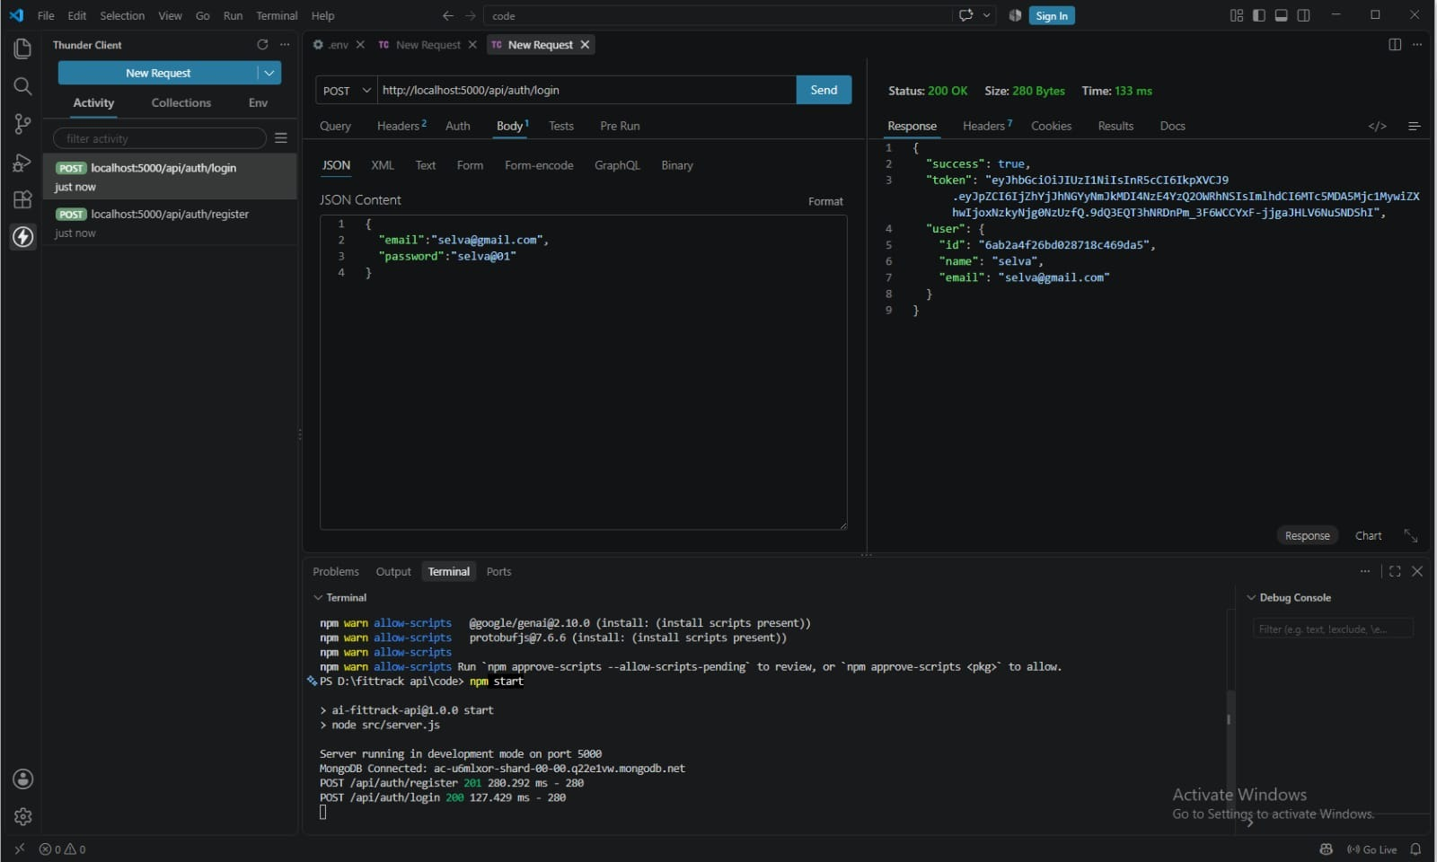  Figure 1: User login – POST /api/auth/login (200 OK, JWT token returned) | 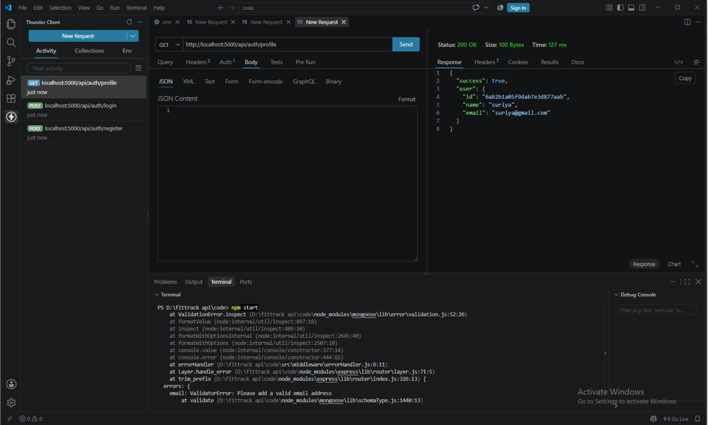  Figure 2: Protected profile – GET /api/auth/profile (200 OK)
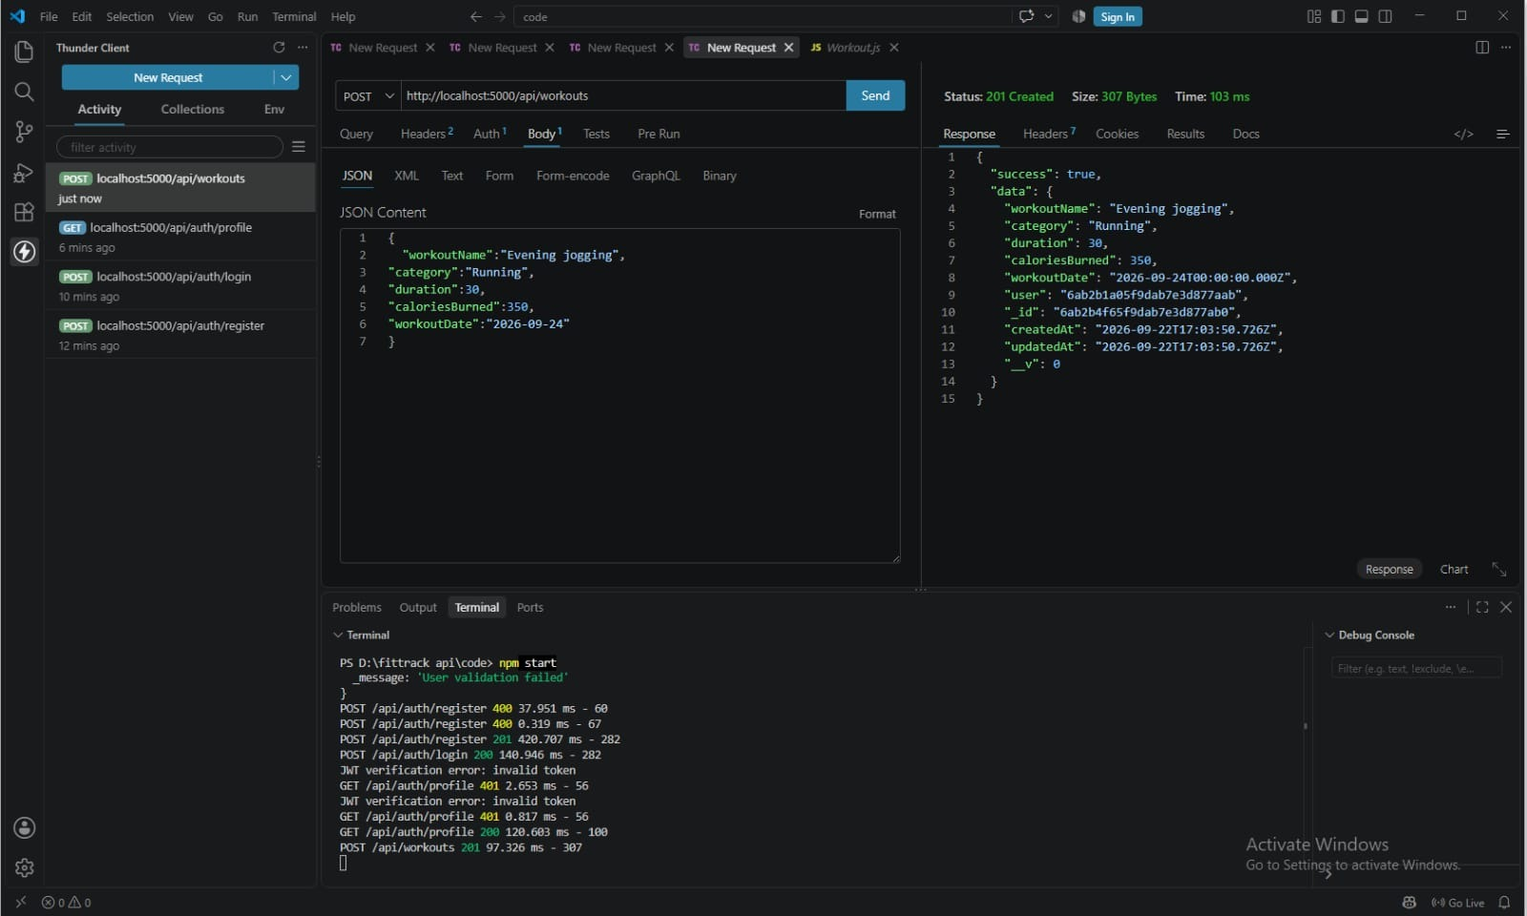  Figure 3: Create record – POST /api/workouts (201 Created) | 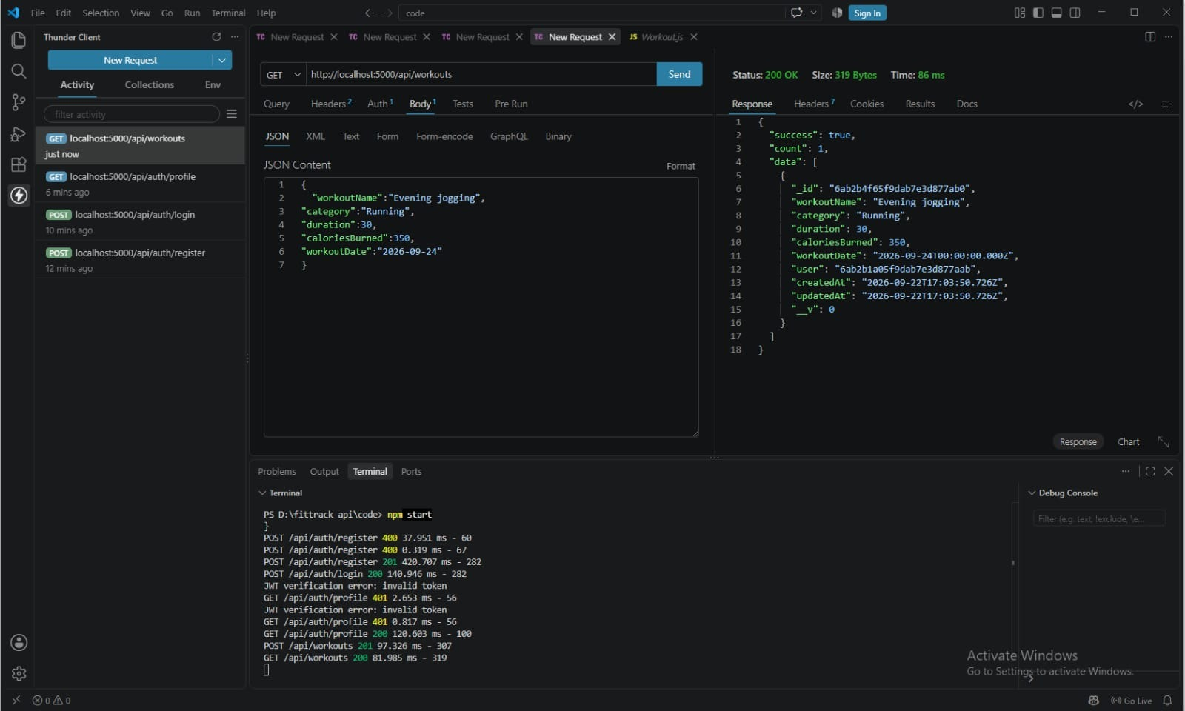  Figure 4: List records – GET /api/workouts (200 OK)

PHASE 7 — PROJECT DOCUMENTATION (CONTINUED)
Screenshots (continued)
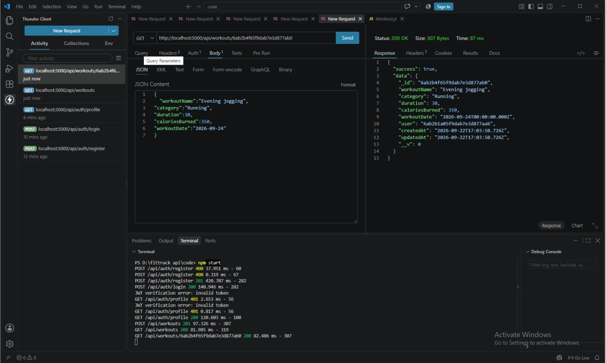  Figure 5: Get one record – GET /api/workouts/:id (200 OK) | 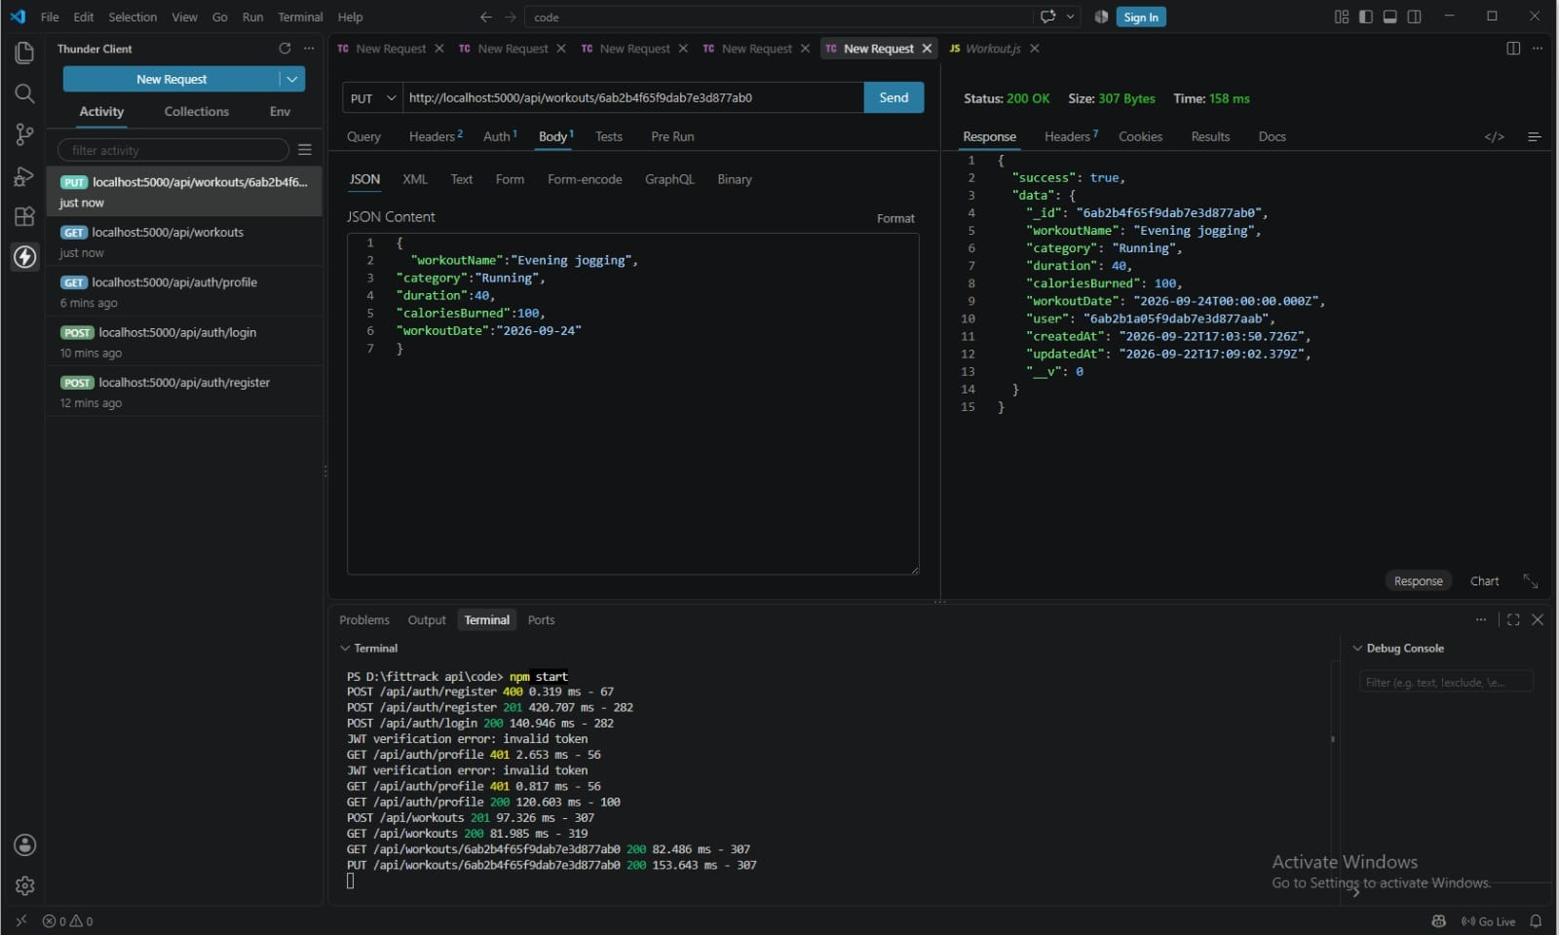  Figure 6: Update record – PUT /api/workouts/:id (200 OK)
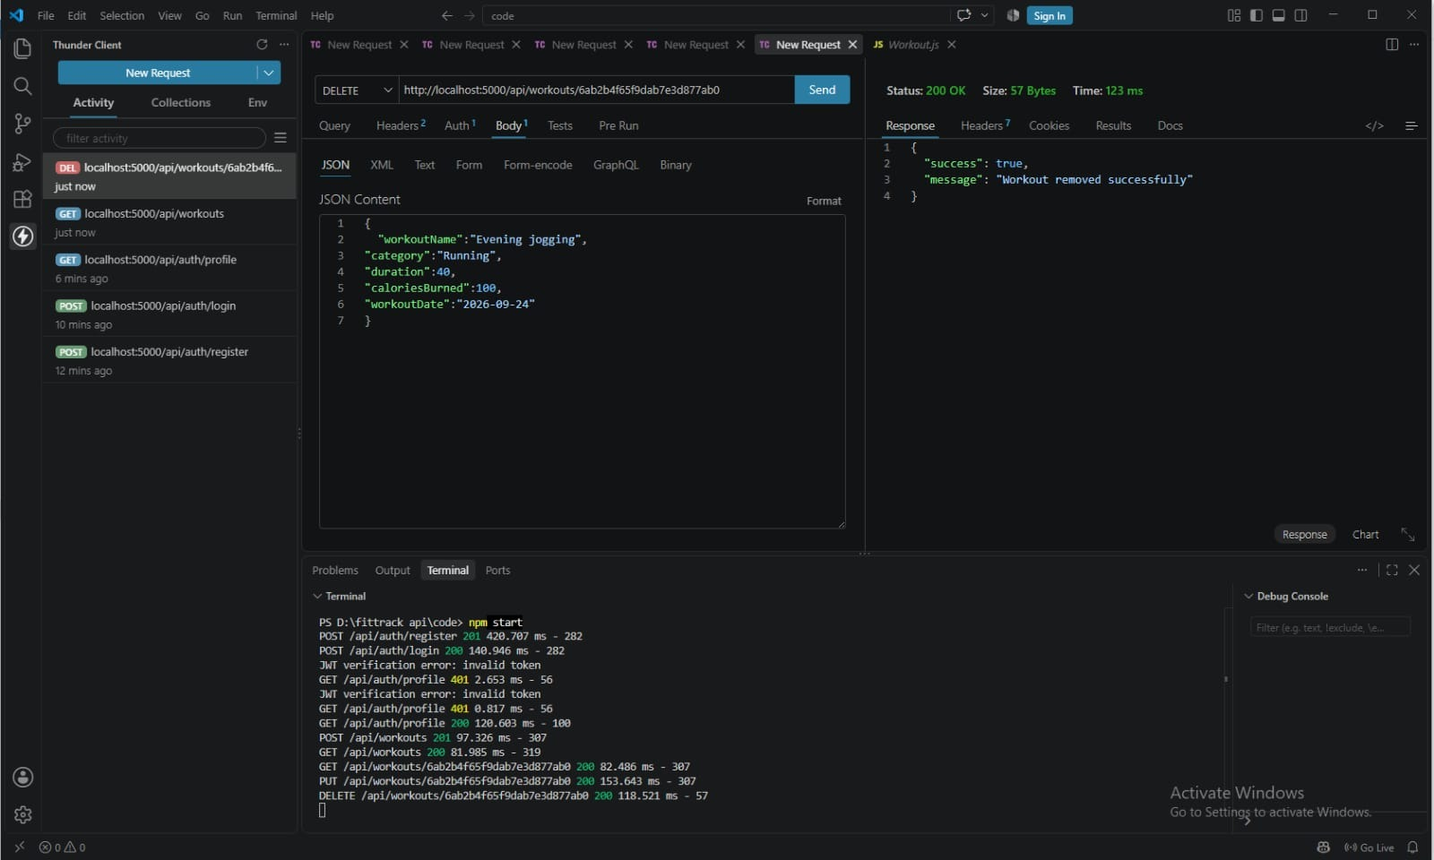  Figure 7: Delete record – DELETE /api/workouts/:id (200 OK) | 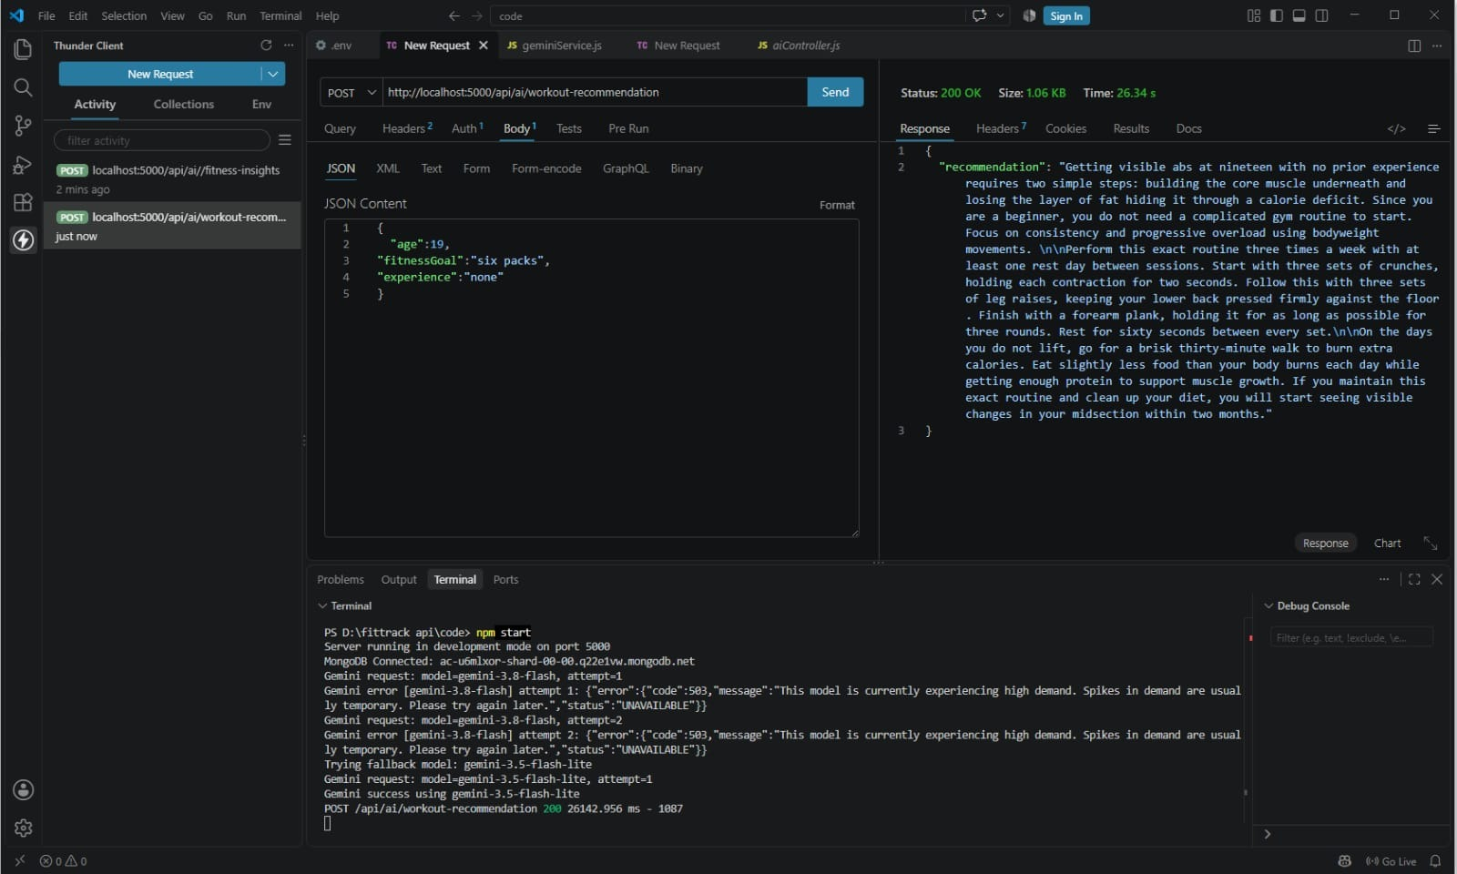  Figure 8: AI generation – POST /api/ai/workout-recommendation (200 OK)
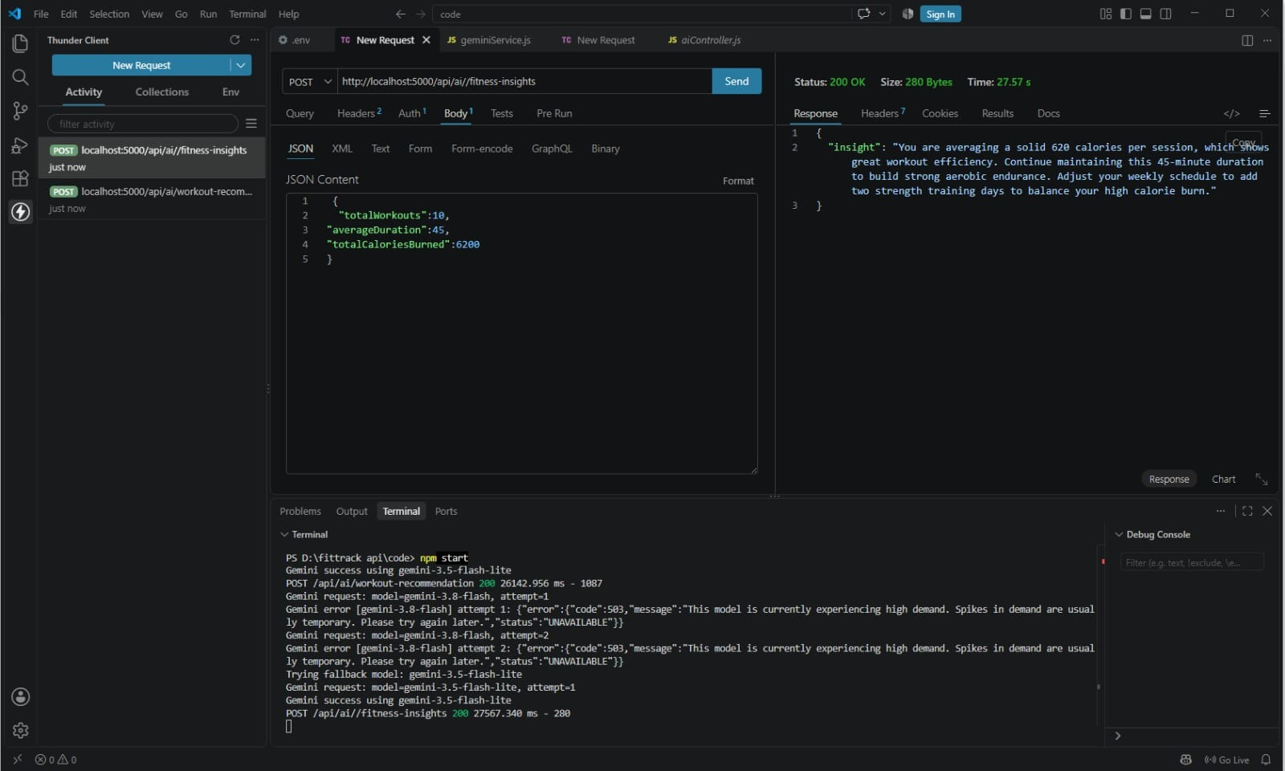
Figure 9: AI generation – POST /api/ai/fitness-insights (200 OK)

PHASE 8 — FINAL SUBMISSION & DEMONSTRATION
INTRODUCTION :
Project Title : BlogNest AI
Team ID : SWTID-2026 4186
Team Leader : Vishal A
MAIL ID: vishalken321@gmail.com
Team members :
NAME | MAIL ID
Hariprakash G | hari623406@gmail.com
Sudharshan S | Sudhansasi30@gmail.com
Final Deliverables
- Working BlogNest AI backend with authentication, blog CRUD, search and AI generation.
- Complete project documentation for all phases.
- Public GitHub repository link and final demo video.
Key Outcomes
- Faster blog creation through AI-generated titles, outlines and drafts.
- Secure, organised blog management with protected access.
- Easy discovery of content through search and categories.
Future Scope
- A frontend web interface for writing and reading blogs.
- SEO suggestions, multi-language support and scheduled publishing.
Conclusion
BlogNest AI shows how AI can simplify blogging by combining content generation, management and secure access in one backend system. The team planned, built and tested the project successfully, and it can be extended with more features in future.

